A Project Report on

**Ahref WebApp**

Submitted to

**Guru Nanak Dev University, Amritsar**

for the partial fulfillment of requirement for the award of the degree

of

**B.Voc. (Software Development)**

**2016-19**

**Submitted By**

**Navjot Singh**

College Roll No.- 13520

Uni. Roll No- 11031600010

**Supervised By**

**Dr. Daljit Kaur Jaspreet Kaur Bains**

Assistant Professor Assistant Professor



**PG Department of Computer Science & IT**

**Lyallpur Khalsa College, Jalandhar**

# INTRODUCTION

## Overview of the project

This report explains all the in-depth details and development process for the Ahref.

Ahref allows you to track, in real-time, the clicks and referrers on the shortened URL and views of the IP-informers and counters generated by our users using our website.

The Ahref web Application provide ability to excess to the normal user to know the geolocation of the target devices. It contains such scripts that capture victim device details whomever click on the payload link.

The main feature of Ahrefis to provide Domain changer script from which user can easily change any kind of domain into custom domain. Even This application locates device with getting latitude and longitude of victim device.

## Motivation

* **Let’s Familiar with Sarahah.com**

Sarahah, which translates to “frankness” or “honesty” in Arabic, essentially allows you to anonymously message others. You can complement them or critique them, and they will have no idea it's you unless you tell them. You can even link it to your Snapchat account. It's been popular in the Middle East and North Africa for some time, but it just recently caught on in America and Europe and America.

* **Business Logic behind Sarahah**

The idea is that you sign up, then send a link to your profile to whomever you want for feedback, even if that means posting it publicly online, and then anyone with that link can anonymously provide feedback. The app logs comments you have received, sent and favorited & there's no way to follow a person or reply to an anonymous message in simple words you cannot find the person how messaged you.

* **What caused Sarahah to be removed from Google Play and iOS App Store?**

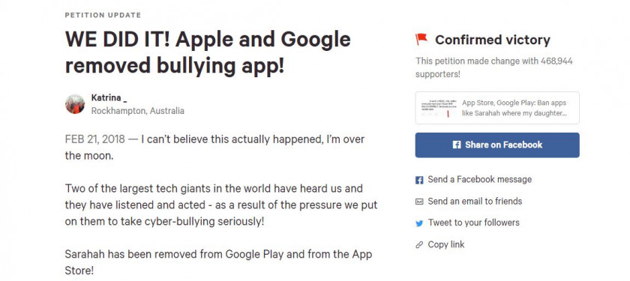

**Fig 1.2.1 News Headlines**

It was begun in January 2018 by Katrina Collins, a mother from Australia who said her 13-year-old daughter had received harassing messages via Sarahah. Collins pointed out that both Google Play and App Store have policies banning apps promoting bullying, and wondered why Sarahah was still available to download. She urged people to put pressure on Apple and Google to get Sarahah and other apps like it banned from those download stores.

So, it inspired me a lot. Every technology has good and bad side effects but the majority of bad thinker is much higher as compare to google thinker so, I had joined Sarahah in 2017 with the same intention to look for what the people nearby me think & know about me. So, I decided to create the account and posted the link on social. Guess what Negatives comments! If someone is same at my position, I am definitely sure he is eager to know who is the suspect So it’s doesn’t bother me about the +ve messages. infect I am curious about, how to this app works! So, I decided to build a sort of way to help peoples like me but before that:

**Couple of question arise in my mind like:**

1. Is there any way to find suspects?

2. If yes, what is it?

3. Should I help others to know their suspect on a Good way without letting know the suspects?

## PROJECT DESCRIPTION

* + 1. **Purpose:**

Ahref web app is design for multiple purpose but for as a normal user the site helps to track analytic Which help bloggers and article writers in order to give them a valuable feedback among users it helps them to track number of viewers and have an eye on the specific url. Also, it has inbuild URL shortening service which allow user to convert any long specify link to short.

## Scope

This web App supports any Browser and Architecture, Security and the accuracy of tracking itself are the scope of this project.

**This application consists of modules like:**

1. URL-shortening Encrypted
2. URL-Shortening Decrypted
3. Tracking Code
4. QR-CODE Generator
5. Login/signup
6. Public Profile
7. Email verification
8. Forgot password
9. ISP detection
10. Host detection
11. USER-AGENT detection
12. IP detection
13. Custom domain generation
14. View counter
15. Email on Every click features
16. Detect BOT-NET(Facebook, twitter)
17. Google Re-Captcha
18. Other famous embed shortening services
19. Note/Memo Option
20. Remove My data
21. Public/private url

## Objectives

The application aims to track user activity and the device information Whomever click on the specific shorten link.

The main objectives of this application are as follows:

* Use in Various organization to check its security level of their systems.
* Helps article/bloggers to short their long URL into short.
* Enhance web experiences(cookies).
* Detection of target devices (gathering information).
* Use in IT business to check the specification of competitor handset